Listed below are dogs who are looking for family homes. All of the dogs have consistently been free walking or running in harness this season and many have been working on their “house skills” spending lots of time indoors. Each dog is updated on all vaccinations and heart worm medications. We require a $100 adoption fee per dog ages 8 and over, Please email or call Tasha with any questions. info@natureskennel.com, 906-748-0513
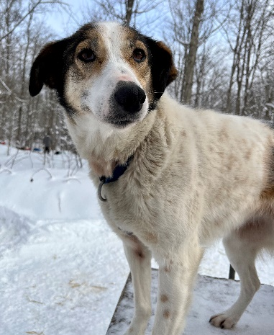  Plum  Female, spayed born 8/19/2014  Plum is very reserved and sweet. She will be shy at first, but we have been working with her to help her get comfortable living indoors. She loves to go for walks and is very gentle and kind. | 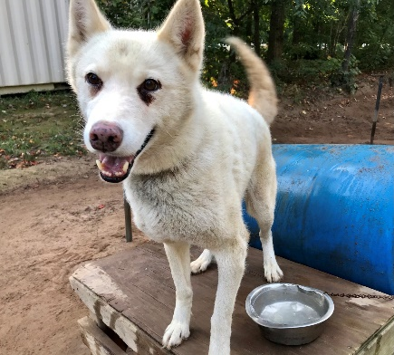  Jelly  Male, date of birth unknown, approximately 9 years old.  Jelly is a super sweet little Siberian husky we rescued several years ago. He has been living full time inside in our guide cabin with the staff, so he’s house trained and ready to snuggle on a couch. He’s always happy, friendly, gets along with all humans and dogs, and would make a great pet. | 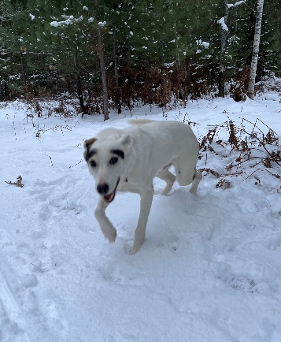  Tex (“Mr. Eyebrows”)  Male, neutered, born 2013  Tex is beyond awesome. He’s very friendly and gets along with all other dogs. He still has lots of energy for his age, but he’s also a great off leash and free walking. He's good in the house and loves to snuggle. He loves kids and would be great in a family home.
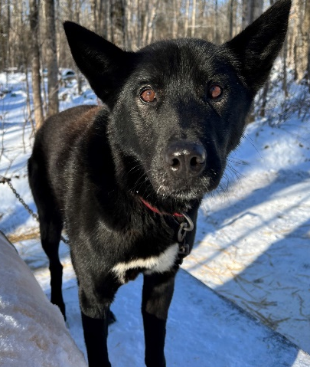  Captain  Male, neutered, born 2012  Captain is a super friendly, calm and sweet dog. He’s currently living indoors and he’s a great snuggle buddy. He’d be best in a single-dog household (or with female dogs) but he loves people and kids. | 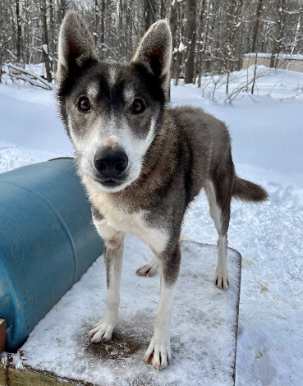  Sherpa  Male, neutered, 2014  Sherpa is a very sweet and social dog. He will love living indoors and snuggling. He’s gentle and gets along great with other dogs. He is great to free walk and he knows his name well. He would be fine in a house with kids. | 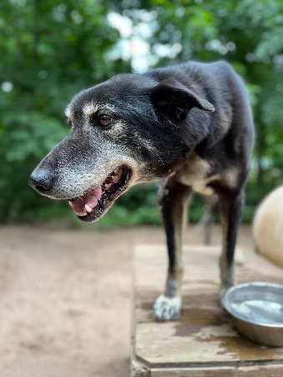  Josh  Male, born 2/19/2013  I feel like Josh has been waiting too long for “his family”. He’s one of our go-to free walkers when we walk dogs, he’s super loving and very social. He’s great off leash and knows his name well.
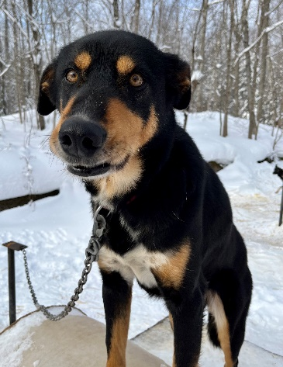  Peck, male, born 2014  Peck is very social and gets along great with other dogs. He’s very calm and would be great in a family home. He love hanging out with his brother, Prairie, and they would do great together if someone wanted two dogs. | 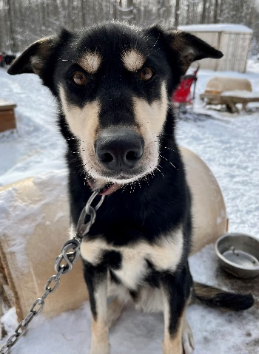  Prairie, neutered male, 2014  Prairie is very social and gets along great with other dogs. He’s very calm and would be great in a family home. He love hanging out with his brother, Peck, and they would do great together if someone wanted two dogs.

